Finding steady ground:
strengthening our spirits to resist and thrive in these times.
To be in shape for the long haul, we have to keep our minds and spirits ready and heart open.
 | 1 | I will make a conscious decision about when and where I'll get news — and what I'll do afterwards.
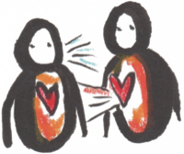 | 2 | I will make human-to-human connection with another person and make sure we stay in motion.
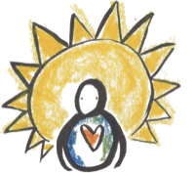 | 3 | I will pray, meditate, or reflect on those I know who are being impacted by oppressive policies, and extend that love to all who may be suffering.
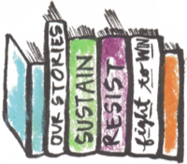 | 4 | I will read, listen to, or share a story about how others have resisted injustice.
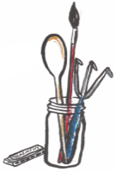 | 5 | I will be aware of myself as one who creates.
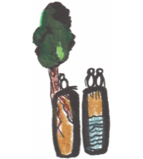 | 6 | I will take a conscious break from social media.
 | 7 | I will commit to sharing with others what’s helping me.

